AI ASSISTED CODING
ASSIGNMENT - 7
NAME: P.SAI SHANKAR
HL-NO: 2303A52500 BATCH: 50
Lab 7.5:
Lab 7: Error Debugging with AI: Systematic approaches to finding and fixing bugs
Lab Objectives:
- To identify and correct syntax, logic, and runtime errors in Python programs using AI tools.
- To understand common programming bugs and AI-assisted debugging suggestions.
- To evaluate how AI explains, detects, and fixes different types of coding errors.
- To build confidence in using AI to perform structured debugging practices.
Lab Outcomes (LOs):
After completing this lab, students will be able to:
- Use AI tools to detect and correct syntax, logic, and runtime errors.
- Interpret AI-suggested bug fixes and explanations.
- Apply systematic debugging strategies supported by AI-generated insights.
Refactor buggy code using responsible and reliable programming patterns.
Task 1 (Mutable Default Argument – Function Bug)
Task: Analyze given code where a mutable default argument causes unexpected behavior. Use AI to fix it. # Bug: Mutable default argument
def add_item(item, items=[]):
items.append(item)
return items
print(add_item(1))
print(add_item(2))
Expected Output: Corrected function avoids shared list bug.
Prompt:- "Analyze the code for mutable default arguments and provide a solution to prevent unexpected behavior.
Code:
from typing import List, Optional, Any, Dict
def add_item(item: Any, items: Optional[List[Any]] = None) -> List[Any]:
"""
Adds an item to a list safely by avoiding mutable default arguments.
"""
if items is None:
items = []
items.append(item)
return items
def update_config(key: str, value: Any, config: Optional[Dict[str, Any]] = None) -> Dict[str, Any]:
"""
Updates a configuration dictionary safely.
"""
if config is None:
config = {}
config[key] = value
return config
# --- Examples and Verification ---
print("--- List Example (Correct Behavior) ---")
print(f"Call 1: {add_item(1)}") # Expected: [1]
print(f"Call 2: {add_item(2)}") # Expected: [2] (Not [1, 2])
print(f"Call 3 with existing: {add_item(3, [10, 20])}") # Expected: [10, 20, 30]

print("\n--- Dictionary Example (Correct Behavior) ---")
print(f"Call 1: {update_config('host', 'localhost')}") # Expected: {'host': 'localhost'}
print(f"Call 2: {update_config('port', 8080)}") # Expected: {'port': 8080}

Output:
--- List Example (Correct Behavior) ---
Call 1: [1]
Call 2: [2]
Call 3 with existing: [10, 20, 3]

--- Dictionary Example (Correct Behavior) ---
Call 1: {'host': 'localhost'}
Call 2: {'port': 8080}

Task 2 (Floating-Point Precision Error)
Task: Analyze given code where floating-point comparison fails.Use AI to correct with tolerance.
# Bug: Floating point precision issue
def check_sum():
return (0.1 + 0.2) == 0.3
print(check_sum())
Expected Output: Corrected function

Prompt:- "Analyze the code for floating-point precision issues and provide a solution using a tolerance for comparison."
Code:
import math

# Floating-Point Precision Issues and Solutions
def is_equal(a, b, rel_tol=1e-9, abs_tol=0.0):
"""
Custom comparison function using a tolerance (epsilon).
- rel_tol: relative tolerance
- abs_tol: absolute tolerance (useful for comparisons near zero)
"""
return abs(a - b) <= max(rel_tol * max(abs(a), abs(b)), abs_tol)
def demo_precision_issues():
# Example 1: Simple addition
a = 0.1 + 0.2
b = 0.3
print("Example 1: 0.1 + 0.2 comparison")
print(f" Exact (==): {a == b}")
print(f" math.isclose(): {math.isclose(a, b)}")
print(f" Custom is_equal: {is_equal(a, b)}")
print("-" * 30)
# Example 2: Cumulative errors
sum_val = sum([0.1] * 10)
print("Example 2: sum([0.1]*10) comparison to 1.0")
print(f" Exact (==): {sum_val == 1.0}")
print(f" math.isclose(): {math.isclose(sum_val, 1.0)}")
print(f" Custom is_equal: {is_equal(sum_val, 1.0)}")
print("-" * 30)
# Example 3: Small numbers near zero
c = 1e-10
d = 0.0
print("Example 3: Comparing 1e-10 to 0.0 with absolute tolerance")
# math.isclose(1e-10, 0.0) defaults rel_tol=1e-09, abs_tol=0.0 -> False
print(f" math.isclose(1e-10, 0.0): {math.isclose(c, d)}")
print(f" math.isclose(1e-10, 0.0, abs_tol=1e-9): {math.isclose(c, d, abs_tol=1e-9)}")
print("-" * 30)
from decimal import Decimal
def financial_example():
print("Example 4: Financial calculations using Decimal module")
price = Decimal('0.70')
tax = Decimal('1.05')
total = price * tax
expected = Decimal('0.735')

print(f" Decimal calculation (0.70 * 1.05): {total}")
print(f" total == 0.735: {total == expected}")

# Standard float comparison for same values
f_price, f_tax = 0.70, 1.05
f_total = f_price * f_tax
print(f" Float calculation (0.70 * 1.05): {f_total:.20f}")
print(f" f_total == 0.735: {f_total == 0.735}")
print("-" * 30)
if __name__ == "__main__":
demo_precision_issues()
financial_example()

Output:
Example 1: 0.1 + 0.2 comparison
Exact (==): False
math.isclose(): True
Custom is_equal: True
------------------------------
Example 2: sum([0.1]*10) comparison to 1.0
Exact (==): True
math.isclose(): True
Custom is_equal: True
------------------------------
Example 3: Comparing 1e-10 to 0.0 with absolute tolerance
math.isclose(1e-10, 0.0): False
math.isclose(1e-10, 0.0, abs_tol=1e-9): True
------------------------------
Example 4: Financial calculations using Decimal module
Decimal calculation (0.70 * 1.05): 0.7350
total == 0.735: True
Float calculation (0.70 * 1.05): 0.73499999999999998668
f_total == 0.735: True
------------------------------

Task 3 (Recursion Error – Missing Base Case)
Task: Analyze given code where recursion runs infinitely due to missing base case. Use AI to fix.
# Bug: No base case
def countdown(n):
print(n)
return countdown(n-1)
countdown(5)
Expected Output : Correct recursion with stopping condition.
Prompt:-"Analyze the code for missing base cases in recursion and provide a solution to implement a stopping condition."
Code:
def countdown(n, message="Countdown finished!"):
"""Counts down from n to 0, printing each number.

Args:
n (int): The starting number for the countdown.
message (str): A message to display when the countdown finishes.
"""
if n < 0:
print("Negative numbers are not allowed.")
return
elif n == 0: # Base case
print(message)
return
print(n)
countdown(n - 1)
# Examples
print("Example 1:")
countdown(5) # Output: 5, 4, 3, 2, 1, Countdown finished!
print("\nExample 2:")
countdown(3) # Output: 3, 2, 1, Countdown finished!
print("\nExample 3:")
countdown(0) # Output: Countdown finished!
print("\nExample 4:")
countdown(-1) # Output: Negative numbers are not allowed.

Output:
Example 1:
5
4
3
2
1
Countdown finished!

Example 2:
3
2
1
Countdown finished!
Example 3:
Countdown finished!
Example 4:
Negative numbers are not allowed.
Task 4 (Dictionary Key Error)
Task: Analyze given code where a missing dictionary key causes error. Use AI to fix it.
# Bug: Accessing non-existing key
def get_value():
data = {"a": 1, "b": 2}
return data["c"]
print(get_value())
Expected Output: Corrected with .get() or error handling.
Prompt:- "Analyze the code for a missing dictionary key error and provide a solution using .get() or error handling to prevent the issue."
Code:
def get_value(data, key, default_value="Key not found"):
"""Retrieves the value for a given key from a dictionary.

Args:
data (dict): The dictionary to search.
key: The key whose value needs to be retrieved.
default_value: The value to return if the key is not found.
Returns:
The value associated with the key, or the default value if the key is missing.
"""
return data.get(key, default_value)
# Example dictionary
data = {"a": 1, "b": 2, "c": 3}
# Examples
print("Example 1: Accessing existing key 'a'")
print(get_value(data, "a")) # Output: 1
print("\nExample 2: Accessing existing key 'b'")
print(get_value(data, "b")) # Output: 2
print("\nExample 3: Accessing existing key 'c'")
print(get_value(data, "c")) # Output: 3
print("\nExample 4: Accessing non-existing key 'd'")
print(get_value(data, "d")) # Output: Key not found
print("\nExample 5: Accessing non-existing key 'e' with custom default value")
print(get_value(data, "e", "Custom default value")) # Output: Custom default value

Output:
Example 1: Accessing existing key 'a'
1

Example 2: Accessing existing key 'b'
2
Example 3: Accessing existing key 'c'
3
Example 4: Accessing non-existing key 'd'
Key not found
Example 5: Accessing non-existing key 'e' with custom default value
Custom default value
Task 5 (Infinite Loop – Wrong Condition)
Task: Analyze given code where loop never ends. Use AI to detect and fix it.
# Bug: Infinite loop
def loop_example():
i = 0
while i < 5:
print(i)
Expected Output: Corrected loop increments i.
Prompt:- "Analyze the code for an infinite loop caused by a wrong condition and provide a solution to ensure the loop terminates correctly."
Code:
def loop_example(limit=5):
"""Prints numbers from 0 to limit - 1.

Args:
limit (int): The upper limit (exclusive) for the loop.
"""
if limit <= 0:
print("Limit must be a positive integer.")
return
for i in range(limit):
print(i)
# Examples
print("Example 1: Default limit (5)")
loop_example() # Output: 0, 1, 2, 3, 4
print("\nExample 2: Custom limit (3)")
loop_example(3) # Output: 0, 1, 2
print("\nExample 3: Custom limit (0)")
loop_example(0) # Output: Limit must be a positive integer.
print("\nExample 4: Custom limit (-2)")
loop_example(-2) # Output: Limit must be a positive integer.

Output:
Example 1: Default limit (5)
0
1
2
3
4

Example 2: Custom limit (3)
0
1
2
Example 3: Custom limit (0)
Limit must be a positive integer.
Example 4: Custom limit (-2)
Limit must be a positive integer.
Task 6 (Unpacking Error – Wrong Variables)
Task: Analyze given code where tuple unpacking fails. Use AI to fix it.
# Bug: Wrong unpacking
a, b = (1, 2, 3)
Expected Output: Correct unpacking or using _ for extra values.
Prompt:"Analyze the code for a tuple unpacking error due to incorrect variable count and provide a solution to correct the unpacking or use _ for extra values."
Code:
def unpack_tuple(data):
"""Unpacks a tuple into variables and handles extra values.

Args:
data (tuple): The tuple to unpack.
Returns:
A tuple containing the first two values and a list of any extra values.
"""
if len(data) < 2:
raise ValueError("Tuple must contain at least two elements.")

# Unpack the first two elements and capture any additional elements
a, b, *rest = data
return a, b, rest
# Examples
print("Example 1: Unpacking a tuple with three elements")
result = unpack_tuple((1, 2, 3))
print(f"a: {result[0]}, b: {result[1]}, rest: {result[2]}") # Output: a: 1, b: 2, rest: [3]
print("\nExample 2: Unpacking a tuple with five elements")
result = unpack_tuple((10, 20, 30, 40, 50))
print(f"a: {result[0]}, b: {result[1]}, rest: {result[2]}") # Output: a: 10, b: 20, rest: [30, 40, 50]
print("\nExample 3: Unpacking a tuple with exactly two elements")
result = unpack_tuple((5, 15))
print(f"a: {result[0]}, b: {result[1]}, rest: {result[2]}") # Output: a: 5, b: 15, rest: []
print("\nExample 4: Attempting to unpack a tuple with one element")
try:
unpack_tuple((42,))
except ValueError as e:
print(e) # Output: Tuple must contain at least two elements.

Output:
Example 1: Unpacking a tuple with three elements
a: 1, b: 2, rest: [3]

Example 2: Unpacking a tuple with five elements
a: 10, b: 20, rest: [30, 40, 50]
Example 3: Unpacking a tuple with exactly two elements
a: 5, b: 15, rest: []
Example 4: Attempting to unpack a tuple with one element
Tuple must contain at least two elements.

Task 7
Prompt : Analyze given code and Fix the code where mixed indentation causes error using AI

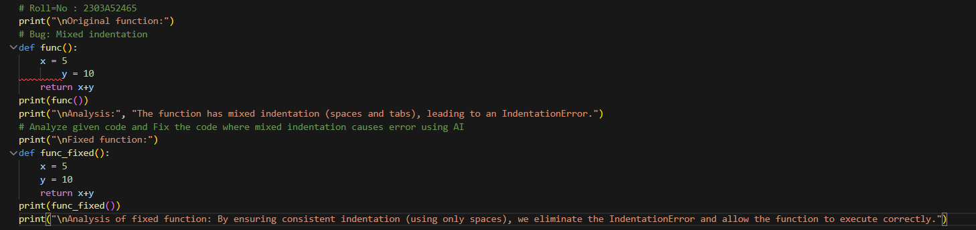
Output :
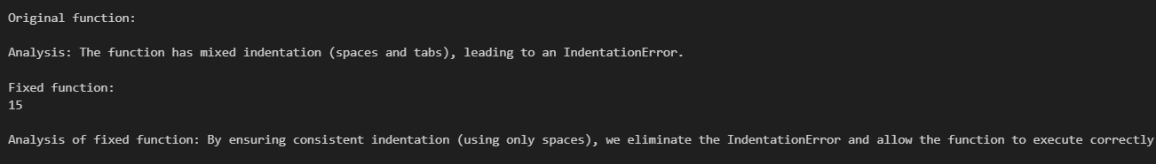

Task-8 :
Prompt : Analyze given code and Fix the code where wrong module is imported using AI
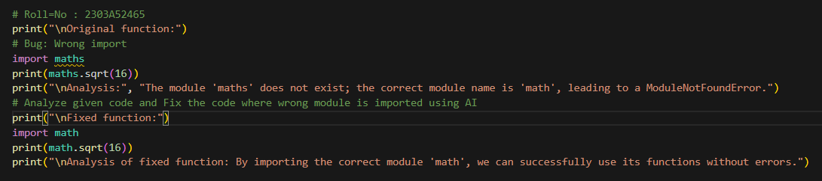
Output :
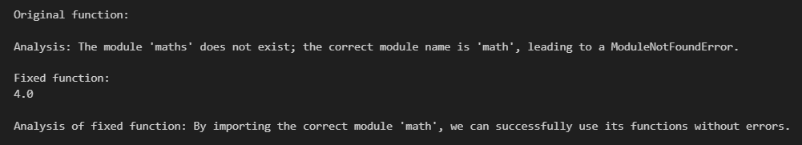

Task-9 :
Prompt : Analyze given code and Fix the code where early return causes function to exit prematurely using AI
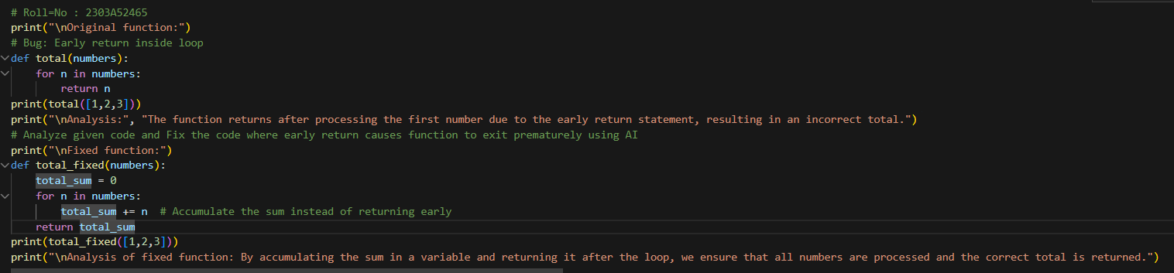
Output :
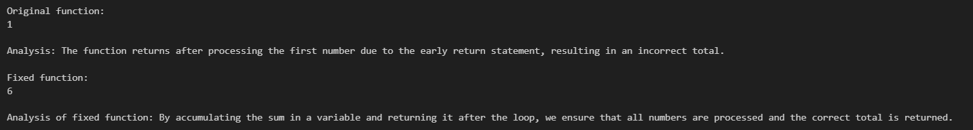

Task-10 :
Prompt : Analyze given code and Fix the code where a variable is used before being defined causing error using AI
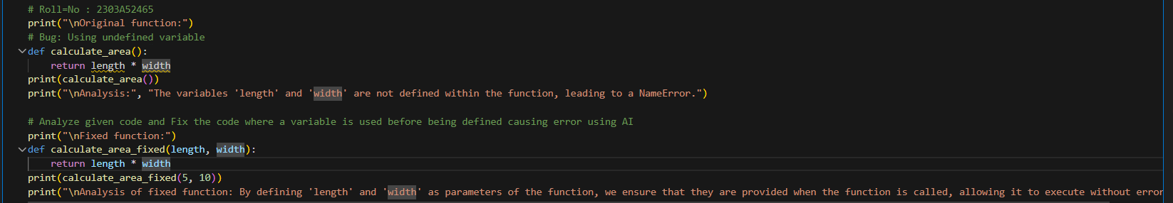
Output :
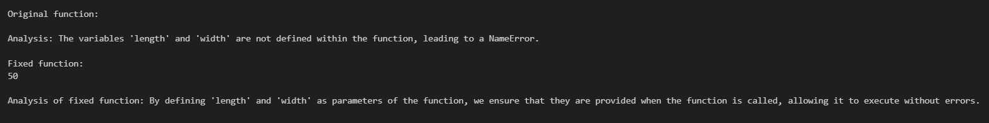

Task-11 :
Prompt : Analyze given code and Fix the code where integers and strings are added incorrectly causes error using AI and verify with 3 test cases
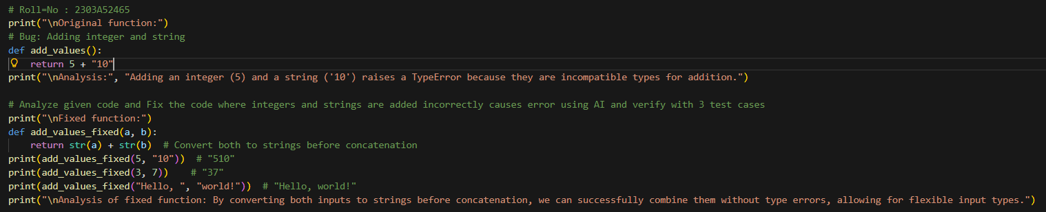
Output :
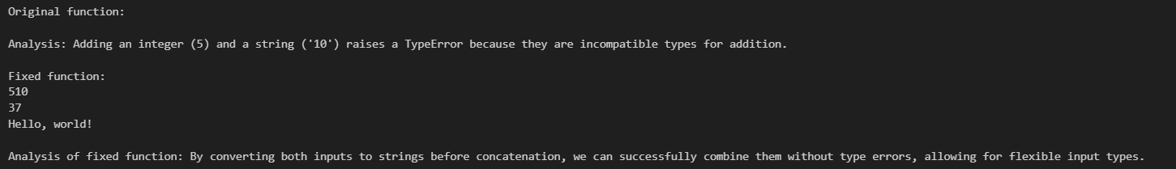

Task-12 :
Prompt : Analyze given code and Fix the code where string and list are added incorrectly causes error using AI and verify with 3 test cases

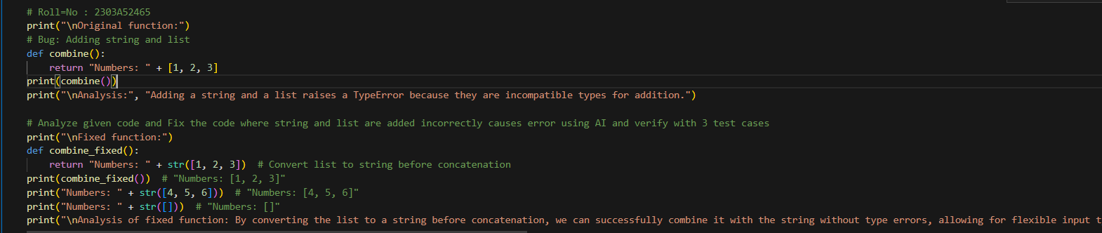
Output :
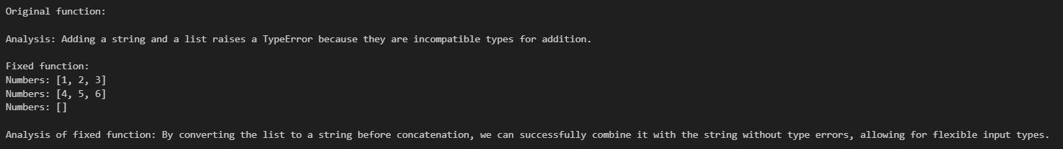

Task-13 :
Prompt : Analyze given code and Fix the code where string is multiplied by a float causing error using AI and verify with 3 test cases

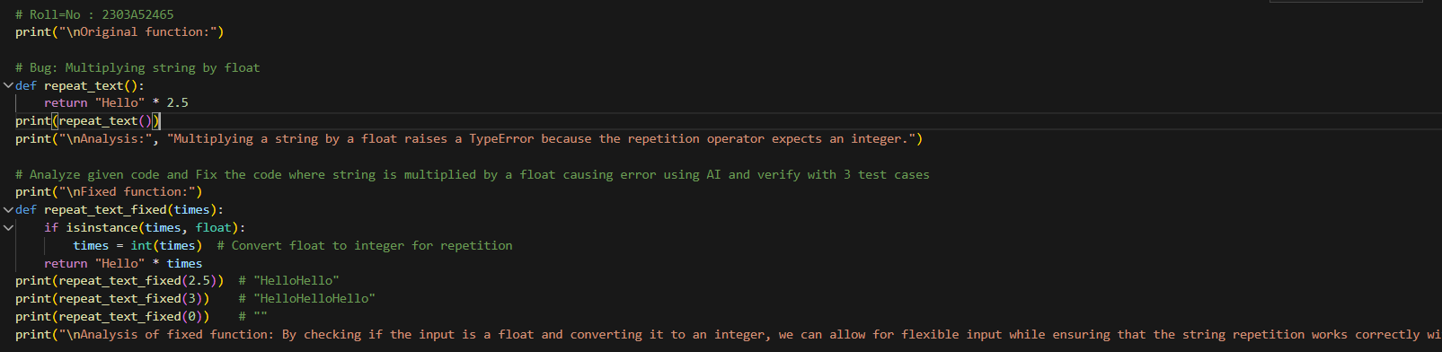
Output :
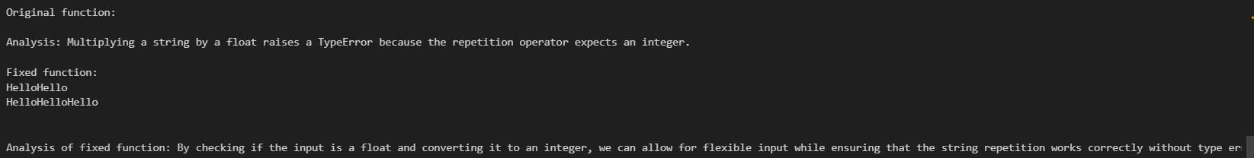

Task-14 :
Prompt : Analyze given code and Fix the code where None is added to an integer causing error using AI and verify with 3 test cases
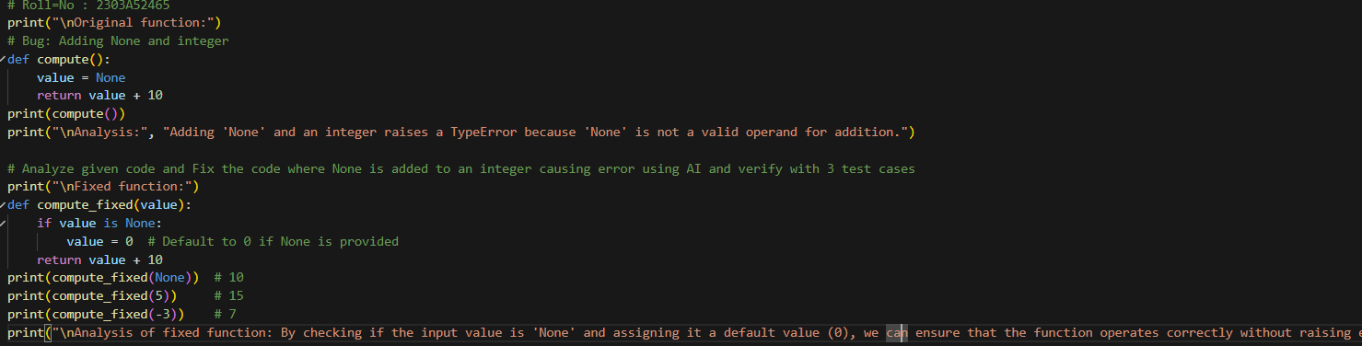
Output :
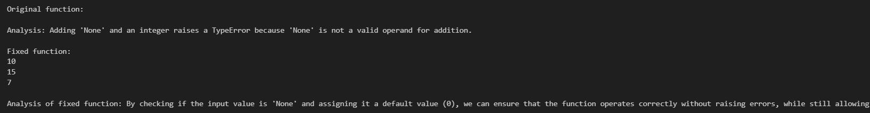
Task-15 :
Prompt : Analyze given code and Fix the code where integers are added as strings causing error using AI and verify with 3 test cases

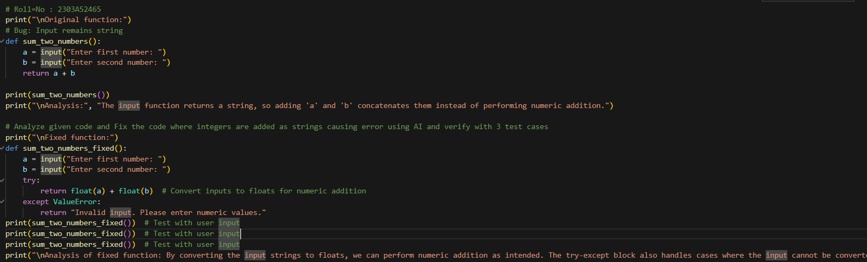
Output :
